Getting Started
This knowledge base runs on DokuWiki with Markdown syntax enabled.
- By default, all areas except /public and /wiki are private.
- Access is granted by administrators to specific areas of the Wiki. Whenever you need access to new wiki sections, contact afeijoo@odins.es or jsanchez@odins.es.
- Broadly speaking, pages and media are structured in folders and sub-folders.
Navigate
On the left hand side of the Wiki you have the sidebar, showing the site-tree with all the folders and pages you have access to. You can also use Sitemapon the top-right hand drop-down menu to get a bigger version on the tree.
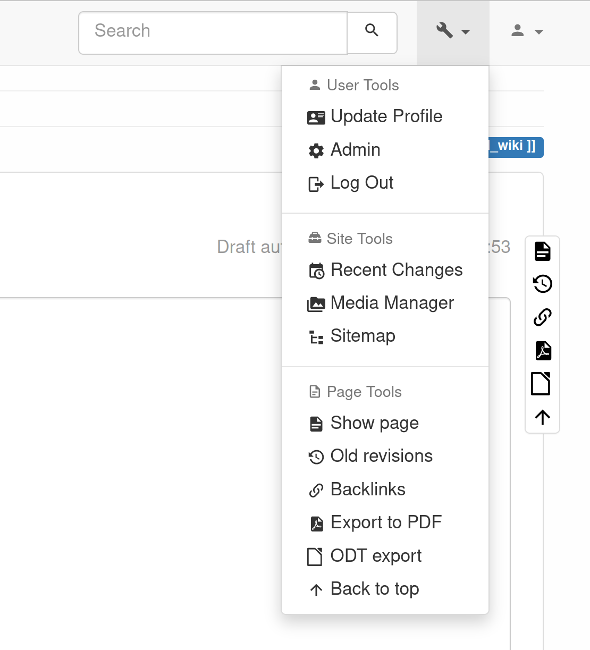
Create a new page
New pages are created specifying the new URI of the resource --e.g. https://wiki.odins.es/public/development/new_page. Once we enter the URI on our browser we are prompted with the following message:
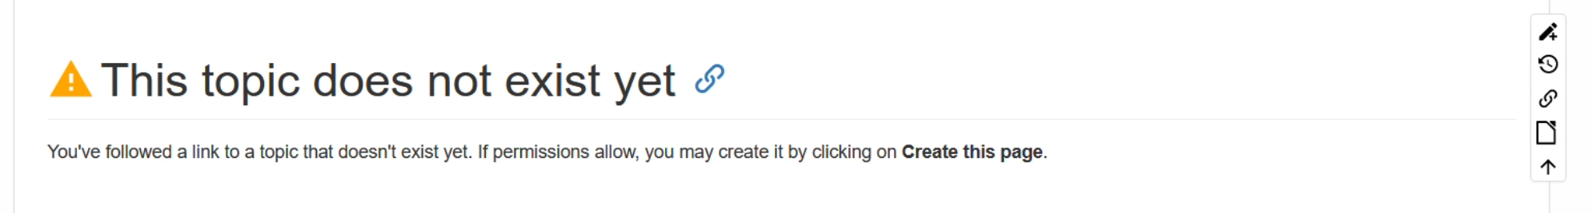
We click on the pencil symbol on the right hand side menu to start editing the page and write whatever we want. The page will be created after saving.
Edit the page
Do not worry about using Markdown. The page editor has a toolbar just like MS Word to edit the text, create tables, bullet lists, etc.
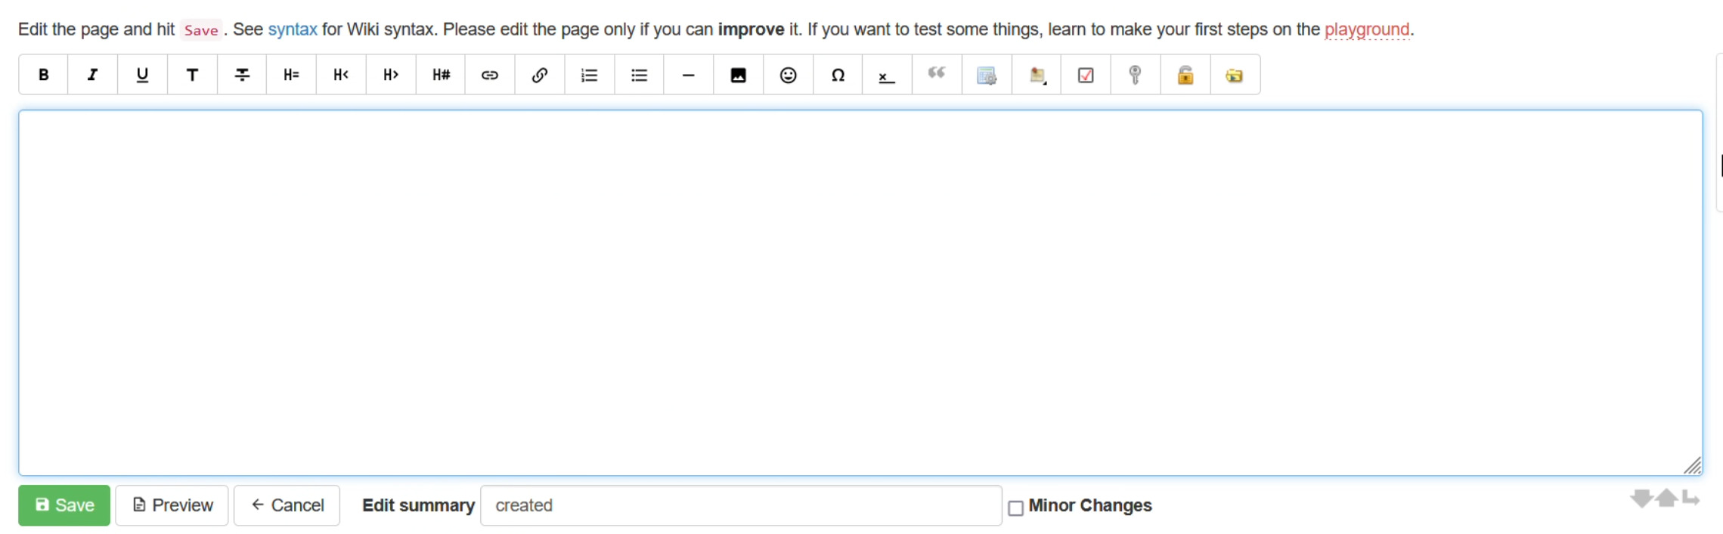
Advanced features
If it's your first time using DokuWiki, please check the DokuWiki foler to learn Dokuwiki advanced features.
Access to Media files such as images or PDFs behaves exactly the same way as regular pages. You'll only access those files if you were given permissions.

Use the Search Bar!
The search bar at the top of this page is quite powerful. We encourage you to use it instead of wasting time browsing the site tree.

